**2025 Autumn term Abacus Brain Program**

* + **Abacus Brain is a programme that uses the abacus as a tactile learning tool to provide brain training for students of all ages. The beauty of the abacus is that anybody can learn it. The art of an abacus education, however, is not to create human calculators, though that may be a notable benefit. Our real goal is to transform the way students think about numbers, and to develop parts of the brain often untouched by conventional maths learning. Research over the years has shown that abacus learning positively impacts working memory and concentration skills, leading to improvement in not only student’s maths scores, but also across all subjects.**
  + The Abacus Brain teaches children the fundamentals of mathematics while improving their focus and concentration skills.  We introduce students to tactile learning while they manipulate the beads of an abacus (Suanpan) with their hands to perform math calculations (addition, subtraction, multiplication, division). Students are taught how to visualize a “mental abacus”, enabling them to perform math calculations in their minds (Xinsuan) without the assistance of a physical abacus. Students benefit from enhanced visualization skills, increased focus & concentration, a higher level of self-confidence, and reinforcement of core math abilities. Abacus math programs also increase the child’s brain development.

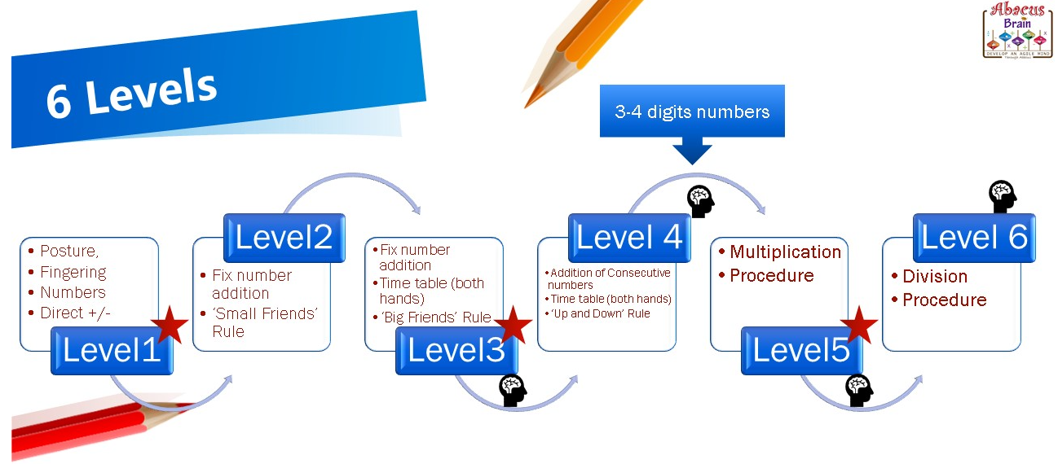

|  |
| --- |
| * 10weeks Monday (15thSeptember-1st, Dec) and Friday (19th, Sep-5th Dec)2025 * Monday Fees: £125(new students) Friday Fees £110 * **Note:** No classes during school half term (w/c 20th and 27th Oct) |

|  |  |  |
| --- | --- | --- |
| * Mon |  | * Friday |
| * 3:15-4:00 Year 1 & 2 new students |  | * 3:15- 4:00 Year 1 & 2 * 4:00-5:00 year 3 plus |

**How to enrol?** Please complete the registration form below and send it with your payment to the school office (please use an envelope and clearly write “Abacus club”)**. Please make cheques payable to Bin Tan or Bank Transfer: nationwide sort code 070436 account number 31993244 please ensure Student’s name is the reference.**

**Registration Form**

**First name: ___________Surname: ________Year Group: ______________**

* + **Date: Monday Friday**
  + **Name of parent: ________ Mobile/Telephone: ________________________**
  + **E-Mail: ____________________________________________________**