A Story About Returning to School

You have been a Superhero and stayed at home. You have done lots of home learning too. There were lots of new rules to follow, like trying to stay 2metres apart from anyone outside your home, sneezing into your elbows and washing your hands for 20 seconds. You’ve even had to stop seeing our friends and family who didn’t live with you.

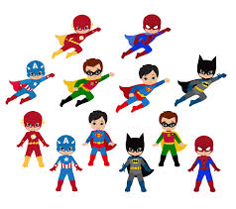

GUESS WHAT? Less people are getting the coronavirus now! Everyone deserves a clap for helping to follow the rules and fighting the virus. You are a superhero!
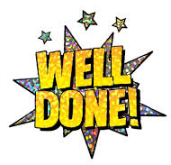
So that we can start to get back to normal, the government have a plan. This plan will help us stay safe and well. It is important that we follow the plan. This means that some children can go back to school now. You might feel worried, excited, happy, sad, scared, shocked or something else. BUT that is ok!
There are lots of people that can help you understand your feelings, like your parents or your teachers. If you talk to them, they can listen.

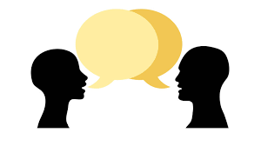

When you come back to school, some things will be the same and some things will be different. Your teachers will help you remember the rules.
Here are some things that will be different:
You will be taught in bubbles, or groups, of children. Some of your friends will be in your bubble, some may be in a different bubble. We can’t play with children in a different bubble, which may make us feel sad, but we can wave at them.
You will need to try to not get too close to your friends, 2 metres is like 3 big steps. This means that your classroom will look different and there may be new playtime games too. You will need to remember to wash your hands more, like when you arrive at school and after playtime.
Your teachers have organised lots of exciting things for you to do at school. You will have lots of fun!
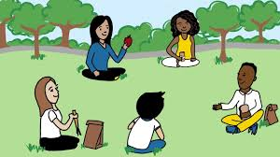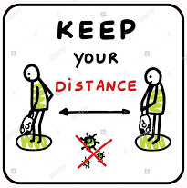

So remember, you will still be a superhero and continue to help fight the virus. Everyone will feel proud of you.
Everyone is looking forward to seeing you back at school too!
