A Story About Returning to School

When you come back to school, the outside may look the same, but on the inside there have been some changes; they will help keep us safe.

You may have lots of different feelings about coming back to school.

There are lots of people that can help you understand your feelings, like your parents or your teachers. If you talk to them, they can listen.

When you come back to school, some things will be the same and some things will be different. There will be some new rules to keep us safe and well. Your teachers will help you remember the rules.
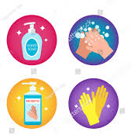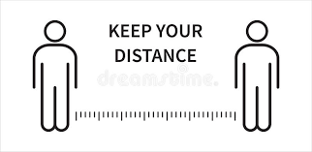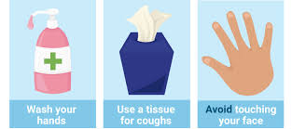

Lots of children will have liked learning at home with their
family. We can still have lots of fun with them after school and at the weekends.

To be a germ buster, we must remember:
- Wash your hands for 20 seconds
- Try not to get too close to others
- Don’t put any objects in your mouth
- Sneeze into your elbow and throw your tissues away
