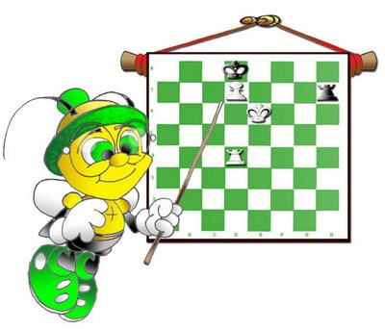
Homefield Chess

Autumn Term 2025
Autumn term starts for chess on the week beginning 15th September and finishes on the week ending 5th December.
Please reply promptly so that the term can start smoothly. Lessons will be conducted by Mr P. Lalic (Candidate Master), or Mr G Buckley (International Master).

The groups are proposed on the following basis.

Mon | Tues | Wed | Thurs | Fri
x | Year 2  (3.15 p.m. – 4 p.m.);  Years 3 - 5 (4p.m. – 5 p.m.) | Year 1 (lunch then chess);  Years 3 - 5 (4p.m. – 5 p.m.) | x | Years 3 - 8 (4p.m. – 5 p.m.)

If you would like your son to join chess club, then please email the responses to me, see below.

Play Chess will endeavour to accommodate all applicants in a suitable session.

The price is £95 for the autumn term. Use a cheque made payable to ‘Play Chess’, or better still,
pay by electronic transfer. Please put the reference as:
HOMEF + surname of child + initial, and send to account:
Sort code: 30-98-36 A/c Number: 29982868 Account Name: PLAY CHESS.

Also, if you are interested in playing chess outside school, please email me if you need help finding events.

Thank you,
Mr. G. Buckley (International Master GNBuckley@aol.com 020 8642 5239)

-------------------------------------------------------------------------------------------------------------------
I wish my child to enrol in chess lessons for the Autumn Term 2025. Please email me the responses.

NAME OF CHILD.........................................................................................Year (in September 2025) ..............

I enclose a cheque for £95 made payable to ‘Play Chess.’ □ or
I have paid electronically. □ Please tick one of the boxes.

Tel No .........................................................................................Preferred club time: …......……………

Please let me know any relevant information about allergies ………………………………………

……………………………………………………………………………………………………….

